Dominic Drury

06/06/2024

CS-405

5-2 Activity: Encryption Coding

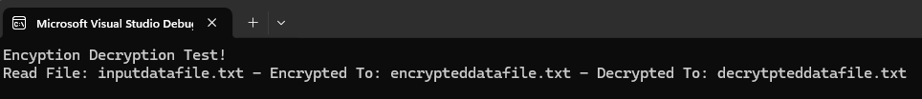

For most of this activity, I needed help from forum pages to remember basic things that I haven’t done in a bit, like reading and writing to a file or getting the current time. I also ran into some trouble when the localTime that I used to use kicked back a warning and I had to use localTime_s which I had never done before. Luckily for me, there were some very helpful forums on StackOverflow and a very handy article on a website called SheCodes. Besides that, the only issues I had were forgetting to add a new line character at the end of each line when creating the string from the file and whether I should empty out the test string so that it was not present in my files. I simply included a “+ \n” to my string at the end of each read line and I did decide to clear out the test string (though I kept it initializing with the original text since it was outside of my TODO sections).